LINEAR REGRESSION ANALYSIS IN R

Exercise

1. Using linear regression analysis establish a relationship between height and weight of a

person using the input vector given below.

# Values of height

151, 174, 138, 186, 128, 136, 179, 163, 152, 131

# Values of weight.

63, 81, 56, 91, 47, 57, 76, 72, 62, 48

Predict the weight of a person with height 170. Visualize the regression graphically.

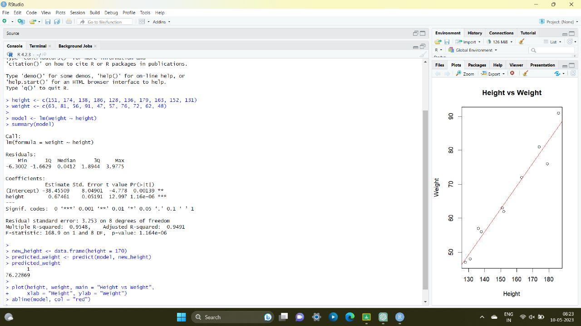

2. Download the Dataset &quot;water&quot; From Rdataset Link.Find out whether there is a linear

relation between attributes&quot;mortality&quot; and&quot;hardness&quot; by plot function.Fit the Data into the

Linear Regression model.Predict the mortality for the hardness=88

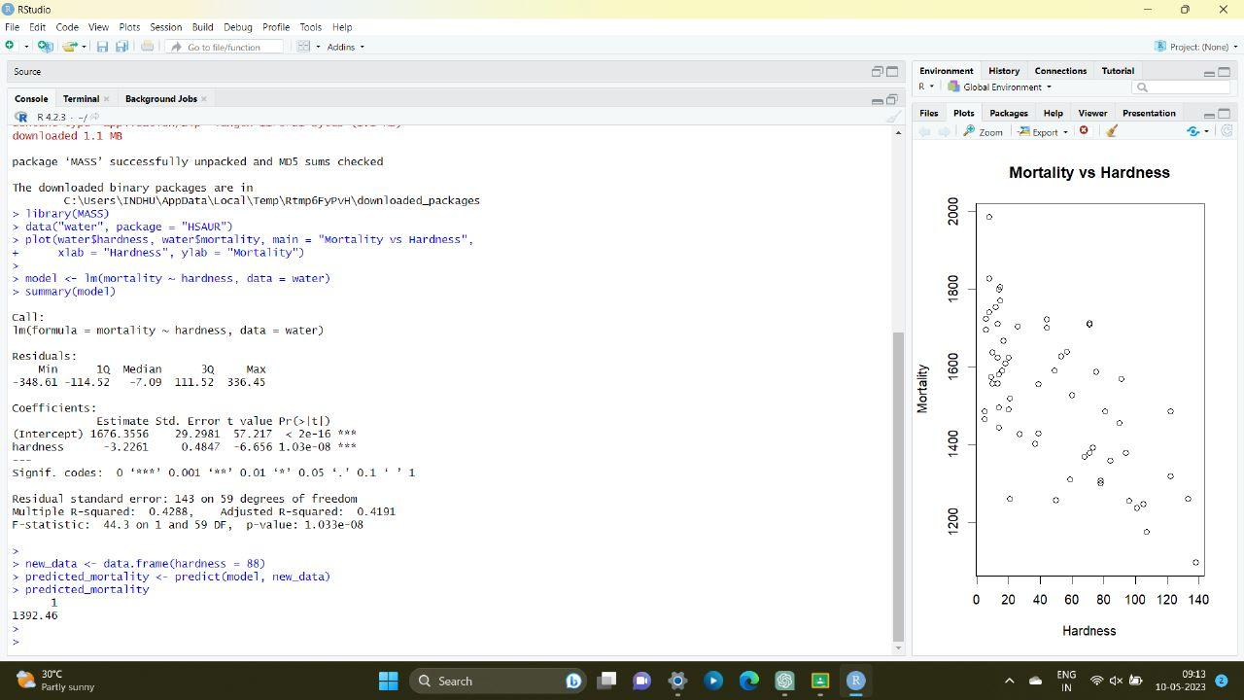

MULTIPLE REGRESSION ANALYSIS IN R

Exercise:

3.Generate a multiple regression model using the built in dataset mtcars.It gives a comparison

between different car models in terms of mileage per gallon (mpg), cylinder

displacement(&quot;disp&quot;), horse power(&quot;hp&quot;), weight of the car(&quot;wt&quot;) and some more parameters.

Establish the relationship between &quot;mpg&quot; as a response variable with &quot;disp&quot;,&quot;hp&quot; and &quot;wt&quot; as

predictor variables. Predict the mileage of the car with dsp=221,hp=102 and wt=2.91.

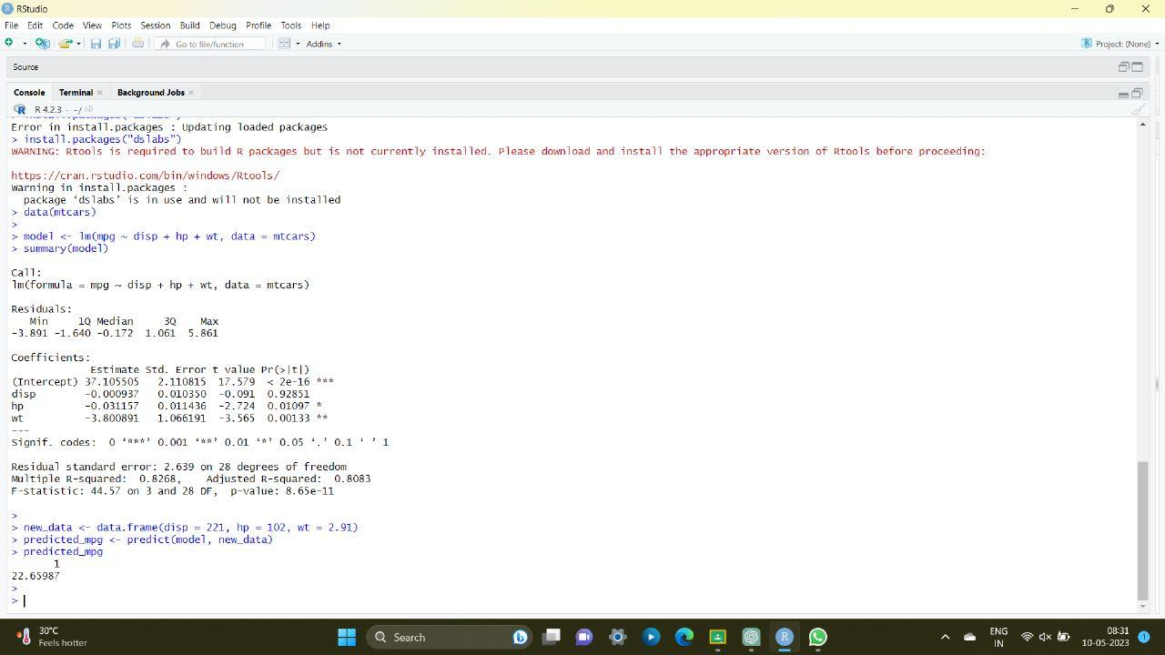

4. Consider the data set &quot;delivery&quot; available in the R environment. It gives a deliverytime

(“delTime”)of production materials(number of productions “n.prod”) with the given

distance(“distance”) to reach the destination place.

a)Create the model to establish the relationship between &quot;delTime&quot; as a response

variable with &quot;n.prod&quot; and &quot;distance&quot; as predictor variables.

b)Predict the delTime for the given number of production(“n.prod”)=9 and

distance(“distance”)=450

